**DBMS Project**

**Facility Management System**

**Team Members:**

* Anjali
* Avinash
* Nandesh
* Sandeep Kumar
* Sarthak Arora

WEEK 1

In the first meeting of our group, the team met and got familiar with each other. We discussed various aspects of our projects.

We started brainstorming our ideas and came up with various vivid ones. Some of these ideas included creating a social network for college, criminal records handling, protein database management, etc.

While discussing these projects, all the team members participated actively and gave intellectual inputs to the ideation. Our group maintained the enthusiasm of passionately working on this project and aimed to make it an actual implementable application.

In the second meeting of the first week, we started with shortlisting the ideas and finally decided upon one. We decided upon redesigning an application for “Facility Management System(FMS)”

The scope of our project is restricted to the services provided by FMS in our college. These services include housekeeping, plumbing, AC repairing, various other electrical problems, etc. All these issues are centrally controlled by contacting a particular help center that can be contacted via various means like calling, texting, WhatsApp, and an online portal.

After deciding upon our topics, we started recognizing the stakeholders.

The following were the recognized stakeholders after the first week's discussion:

* Students
* Faculty
* Individuals from different eateries.
* Cleaners, electricians, mechanics, carpenters, and other skilled laborers.
* Heads at FMS

WEEK 2

We started conducting surveys and interviews. We even had informal discussions with various people involved.

We started by contacting Mr. Tinku, an FMS in charge of our college. Mr. Tinku manages all the requests and complaints about the FMS by the students, faculty, and eateries. Mr. Tinku told us that most of the people don't use the portal made explicitly for this purpose. During our 20-25 minute visit to Mr. Tinku, he attended more than 6-7 phone calls and responded to a minimum of 5 WhatsApp messages regarding FMS services.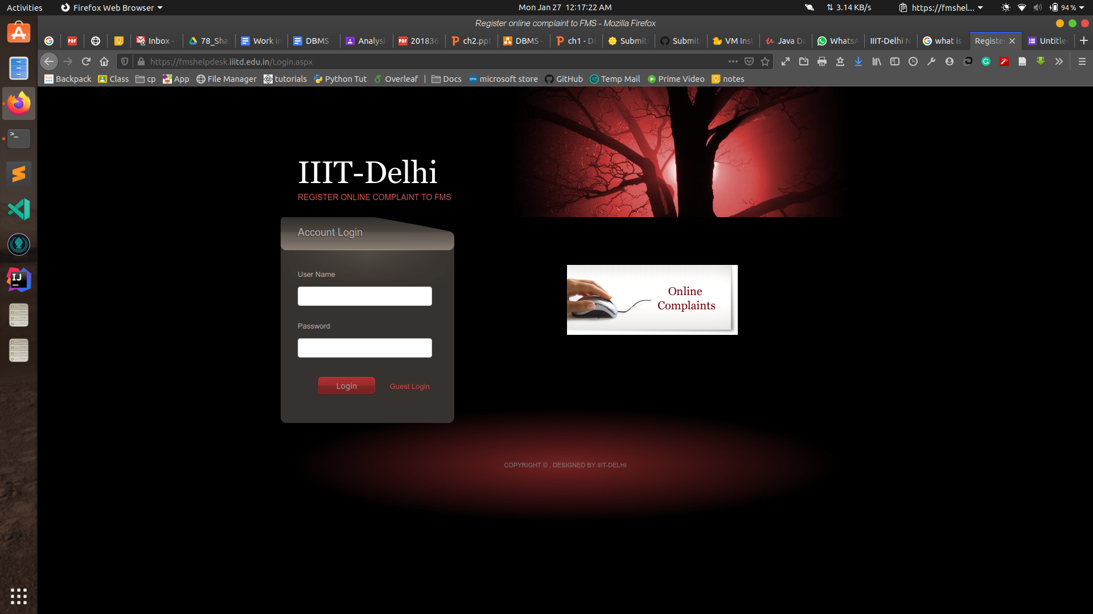

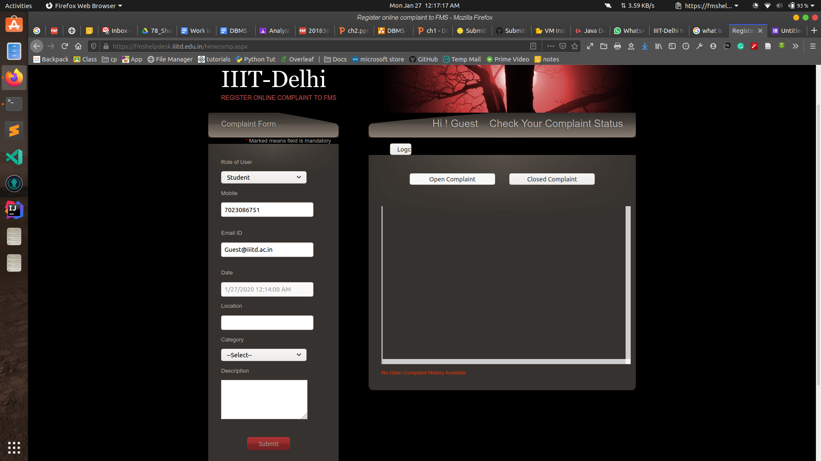

He even told us various drawbacks of the present portal service. Certain drawbacks he listed were:

1. Supervisors don't get a direct SMS after assigning.
2. They have to maintain a separate offline excel database, which is entered manually.
3. There are pretty limited searching options on their platform.
4. There is no way of checking the attendance of the employee, which at times leads to redundancy in the assignment of tasks.
5. There is no facility as an automatic assignment of tasks.
6. There is no facility for editing the details of an employee.

Tinku Sir even made us aware that there was a stakeholder that we were missing all together till now, the supervisors of workers. The FMS heads assign various tasks to the block supervisors, who further assigns the tasks to the workers.

After understanding the whole procedure of how the FMS department is working, we re-finalized our stakeholders:

* Students
* Faculty
* Individuals from different eateries.
* Supervisors
* Cleaners, electricians, mechanics, carpenters, and other skilled laborers. (Indirect stakeholders, they don't use the platform)
* Heads at FMS

By incorporating the suggested improvements in our portal, we can improve the time utility of the FMS heads in the following manner:

1. They would have to attend fewer phone calls as the majority of requests will be shifted to the mobile application/ portal.
2. They wouldn't have to maintain a separate database.
3. There would be more searching options on the portal.
4. There would be a facility for editing the details of an employee.
5. There would be a facility for checking the attendance and working days and time slots of any particular employee.

Then, we started by floating a survey among students and faculty of our college. The study had a simple questionnaire:

1. How often do you use FMS services?
2. Are you aware of the online portal for availing FMS Services?

The results of this study are available below:

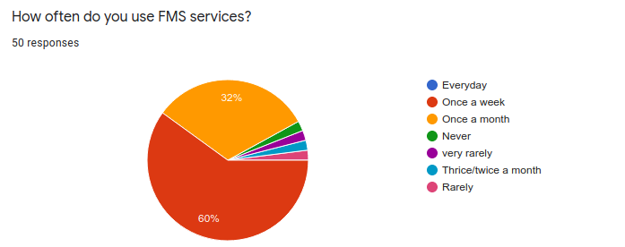

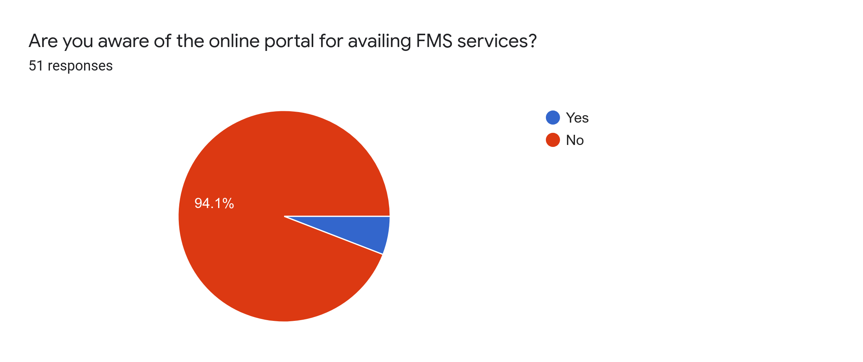

Our study clearly showed that even though the services provided by FMS are used pretty often, most of the students are unaware of the existence of the FMS portal.

By providing a dedicated and improved portal, we'll help the students and faculty in the following ways:

1. They can schedule FMS services.
2. They can keep track of their past usage.
3. They can give a review of the service.
4. They'll get one-touch access to all the services provided by FMS.
5. They can also request for special events that happen around the campus.

Next, we contacted different eateries around the campus, even they were unaware of the existence of the online portal for FMS services.

By providing a dedicated and improved portal, we'll help different eateries in the following ways:

1. They can schedule dustbin pickups.
2. They can ask for emergency pickups.
3. They can give a review of the service.
4. They'll get one-touch access to all the services provided by FMS.
5. They can keep track of their past usage.

At last, we contacted the supervisors and got to know how they were involved in the whole system. We got to know that yet now, all their communication was on phone call and WhatsApp. They assigned all the tasks to random workers and, at times, lost contact with attendance and the working schedule of workers.

Through their input in the discussion, we'll help the students and faculty in the following ways:

1. They can keep track of assigned work to workers in real-time.
2. They can keep track of the attendance of the workers.
3. The app will automatically show the workers that are available for work.
4. It will lead to more coordination between the FMS head and the supervisors.
5. They would have to attend fewer phone calls as the majority of the work would be shifted to the portal/app.

Week 3

**Schema Diagram:**

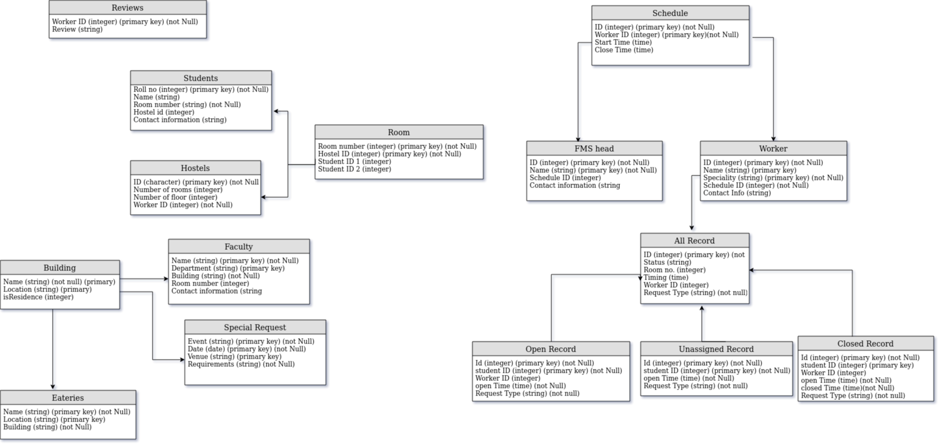

Some of the constraints that were recognized were:

* NOT NULL:

“Students” table we have used not null in “ID” ,”Room no”.,”Name”

* PRIMARY KEY

“Schedule” table has two columns “ID”, “WorkerID” are primary keys

* FOREIGN KEY

“WorkerID” in table “Worker” is a foreign key for table “AllRecord”

* CHECK

In “Worker” table we have used CHECK to make sure that “Speciality” of a worker can only be “cleaner”,”carpenter”,”electrician”,”painter”,”plumber”

In “Room” table we have used CHECK constraint to make sure that “HostelID” can only be (1,2,3)

**WEEK-4**

We started this week by creating tables in our database. All the members were involved in this process and this was done using MySQL Workbench.

All the team members collectively sat to make the tables and populated them.

The following were some commands that were used to create the tables:

_______________________________________________

*CREATE TABLE `AllRecord` (*

*`ID` int(11) NOT NULL,*

*`Status` varchar(10) COLLATE utf8_unicode_ci DEFAULT NULL,*

*`RoomNum` int(11) DEFAULT NULL,*

*`Timing` time DEFAULT NULL,*

*`WorkerID` int(11) DEFAULT NULL,*

*`RequestType` varchar(15) COLLATE utf8_unicode_ci NOT NULL,*

*PRIMARY KEY (`ID`),*

*UNIQUE KEY `ID_UNIQUE` (`ID`),*

*CONSTRAINT `AllRecord_ibfk_1` FOREIGN KEY (`ID`) REFERENCES `ClosedRecord` (`id`) ON DELETE CASCADE ON UPDATE CASCADE,*

*CONSTRAINT `AllRecord_ibfk_2` FOREIGN KEY (`ID`) REFERENCES `OpenRecord` (`ID`) ON DELETE CASCADE ON UPDATE CASCADE,*

*CONSTRAINT `AllRecord_ibfk_3` FOREIGN KEY (`ID`) REFERENCES `UnassignedRecord` (`id`) ON DELETE CASCADE ON UPDATE CASCADE,*

*CONSTRAINT `AllRecord_chk_1` CHECK ((`RequestType` in (_utf8mb3'Cleaner',_utf8mb3'Plumber',_utf8mb3'Electrician',_utf8mb3'Carpenter',_utf8mb3'Painter'))),*

*CONSTRAINT `AllRecord_chk_2` CHECK ((`Status` in (_utf8mb4'Open',_utf8mb4'Close',_utf8mb4'Unassigned')))*

*)*

_______________________________________________

*CREATE TABLE `Hostels` (*

*`ID` int(11) NOT NULL,*

*`NumOfRoom` int(11) DEFAULT NULL,*

*`NumOfFloor` int(11) DEFAULT NULL,*

*`SupervisorID` int(11) NOT NULL,*

*PRIMARY KEY (`ID`),*

*UNIQUE KEY `ID_UNIQUE` (`ID`),*

*KEY `SupervisorID` (`SupervisorID`),*

*CONSTRAINT `Hostels_ibfk_1` FOREIGN KEY (`SupervisorID`) REFERENCES `Supervisor` (`id`) ON DELETE RESTRICT ON UPDATE RESTRICT*

*)*

_______________________________________________

Queries for creating other tables are attached to this document.

The following were some commands that were used to insert data into the tables:

*INSERT INTO `Worker` VALUES (1,'Swastik','Cleaner','12345',1),(2,'Navya','Electrician','23456',2),(3,'Nitin','Plumber','34567',3),(4,'Arka','Carpenter','45678',4),(5,'Kinshuk','Cleaner','56789',5),(6,'Rishabh','Painter','98990',2),(7,'Dhruv','Plumber','88605',4),(8,'Pratham','Carpenter','93129',1),(9,'Yash','Electrician','93503',1),(10,'Naman','Cleaner','55500',3);*

_______________________________________________

*INSERT INTO `UnassignedRecord` VALUES (1,3,'03:00:23','Cleaner'),(2,4,'12:00:59','Carpenter'),(3,9,'04:12:36','Electrician'),(4,5,'05:35:56','Plumber');*

_______________________________________________

Queries for inserting data into other tables are attached to this document.